# **Which are the happiest countries in the world? Norway 1st, Canada 7th**

***By* Seth Borenstein The Associated Press**

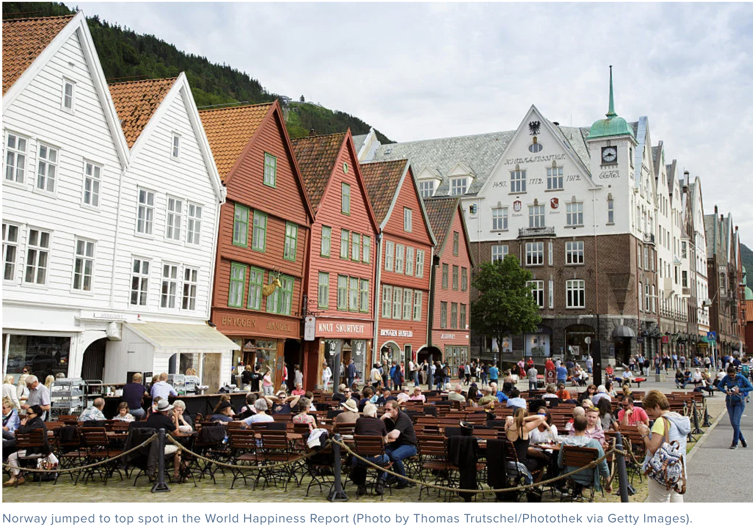

WASHINGTON – If you want to go to your happy place, you need more than cash. A winter coat helps – and a sense of community.



A [new report shows](http://worldhappiness.report/faq/) Norway is the happiest country on Earth, Americans are getting sadder, and it takes more than just money to be happy.

Norway vaulted to the top slot in the [World Happiness Report](http://worldhappiness.report/) despite the plummeting price of oil, a key part of its economy. Income in the United States has gone up over the past decade, but happiness is declining.

The United States was 14th in the latest ranking, down from No. 13 last year, and over the years Americans steadily have been rating themselves less happy.

“It’s the human things that matter. If the riches make it harder to have frequent and trustworthy relationship between people, is it worth it?” asked John Helliwell, the lead author of the report and an economist at the University of British Columbia in Canada (ranked No. 7). “The material can stand in the way of the human.”

Studying happiness may seem frivolous, but serious academics have long been calling for more testing about people’s emotional well-being, especially in the United States. In 2013, the National Academy of Sciences issued a report recommending that federal statistics and surveys, which normally deal with income, spending, health and housing, include a few extra questions on happiness because it would lead to better policy that affects people’s lives.

Norway moved from No. 4 to the top spot in the report’s rankings, which combine economic, health and polling data compiled by economists that are averaged over three years from 2014 to 2016. Norway edged past previous champ Denmark, which fell to second. Iceland, Switzerland and Finland round out the top 5.

“Good for them. I don’t think Denmark has a monopoly on happiness,” said Meik Wiking, chief executive officer of the Happiness Research Institute in Copenhagen, who wasn’t part of the global scientific study that came out with the rankings.

“What works in the Nordic countries is a sense of community and understanding in the common good,” Wiking said.

Still, you have to have some money to be happy, which is why most of the bottom countries are in desperate poverty. But at a certain point extra money doesn’t buy extra happiness, Helliwell and others said.

Central African Republic fell to last on the happiness list, and is joined at the bottom by Burundi, Tanzania, Syria and Rwanda.

The report ranks 155 countries. The economists have been ranking countries since 2012, but the data used goes back farther so the economists can judge trends.

The rankings are based on gross domestic product per person, healthy life expectancy with four factors from global surveys. In those surveys, people give scores from 1 to 10 on how much social support they feel they have if something goes wrong, their freedom to make their own life choices, their sense of how corrupt their society is and how generous they are.

While most countries were either getting happier or at least treading water, America’s happiness score dropped 5 per cent over the past decade. Venezuela and the Central African Republic slipped the most over the past decade. Nicaragua and Latvia increased the most.

Study co-author and economist Jeffrey Sachs of Columbia University said in a phone interview from Oslo that the sense of community, so strong in Norway, is deteriorating in the United States.

“We’re becoming more and more mean spirited. And our government is becoming more and more corrupt. And inequality is rising,” Sachs said, citing research and analysis he conducted on America’s declining happiness for the report. “It’s a long-term trend and conditions are getting worse.”

University of Maryland’s Carol Graham, who wasn’t a study author but did review some chapters, said the report mimics what she sees in the American rural areas, where her research shows poor whites have a deeper lack of hope, which she connects to rises in addictions to painkillers and suicide among that group.

“There is deep misery in the heartland,” Graham, author of the book “The Pursuit of Happiness,” wrote in an email.

Happiness – and doing what you love – is more important than politicians think, said study author Helliwell. He rated his personal happiness a 9 on a 1-to-10 scale.